**우진 - 혜원 - 채희 - 희재 - 미란 - 혁 - 동준 - 고운**

**혜원 - 동준 - 혁 - 고운 - 우진 - 희재 - 채희 - 미란**

***2019.09.09 (Woojin)***

Done

1. Setting up ‘SDR’ in a Linux computer for radio signal test.

* Finish installing and updating a ‘USRP’ program.

1. Assembling an Arduino

* Researching the Arduino and Arduino parts
* Assembling a LCD part for the Arduino test

To do

1. Find out how to use the ‘USRP’ program
2. Make a project plan and create item list we need to buy

***2019.09.10 (Hyewon)***

Done

1. Checked SDR receiving RFs from BF-F8HP
2. Found Github link reference for GNU Radio
3. Discussing with Prof. Smith about how to compare head-to-head LoRa and APRS

* Use two different Raspberry Pis
* Only one SDR

1. Finish to assemble ‘Agrositter’ Arduino circuit

To Do

1. Build a transmitter that acts like (BF-F8HP)
2. Break down APRS_RX_RTL.py file and decide how to modify the receiver end
3. Search for related papers to contribute.
4. Order list of equipments to buy.
5. Make a chat group with summer participants.

* Ask about HX1 antenna
* Final Arduino code of ‘Agrositter’

1. Test Arduino circuit transmit the radio signal

***2019.09.11***

Done

1. Ordered list of equipments to buy.
2. Made a chat group with the summer participant.
3. Succeed testing LoRa GPS transmitting and receiving packets using Arduino
4. Set up ‘SDR’ in the team member’s own laptop for radio signal test.
5. Testing temperature/ humidity sensor and GPS sensor with Arduino
6. Change APRS Arduino circuit scheme
7. Testing APRS radio signal with last team’s Arduino code

To Do

1. Run LoRa code that last year’s team used
2. Test APRS board’s GPS data
3. Make a circuit diagram of APRS Arduino

***2019.09.12***

Done

1. Testing temperature/ humidity sensor and GPS sensor with Arduino
2. APRS signal test using Arduino
3. LoRa signal test using Raspberry Pi

To Do

1. Figure out a way to receive data from GPS sensor (currently not working)
2. Understand previous team’s LoRa code
3. Keep working on drawing circuit diagram of APRS Arduino

***2019.09.13***

Done

1. drawing circuit diagram of APRS Arduino

To Do

1. Figure out a way to receive data from GPS sensor (currently not working)
2. Understand previous team’s LoRa code

***2019.09.16 (Hyuk)***

Done

1. Test the distance of APRS network.
   1. less than 1m

To Do

1. increase the network distance

***2019.09.17 (Dongjun)***

Done

1. Had meeting with professor Smith
2. Changed LoRa transmitting and receiving code for LoRa shield with Arduino

To Do

1. Keep working on connecting antenna to GND
2. Keep testing LoRa outside until the distance becomes over 100m

***2019.09.18 (Gowoon)***

Done

1. Finished editing LoRa code and tested LoRa transmitter and receiver outside (distance : 0.6 miles ~= 956m) <https://goo.gl/maps/i2NW7g9f3QgDD2wB6>
2. Did soldering to antenna adaptor and jumper cable
3. Changed the circuit for APRS ( connect between antenna and gnd ) and tested transmit distance
4. Changed the location of connection between SDR and Antenna (TX/RX->RX2)

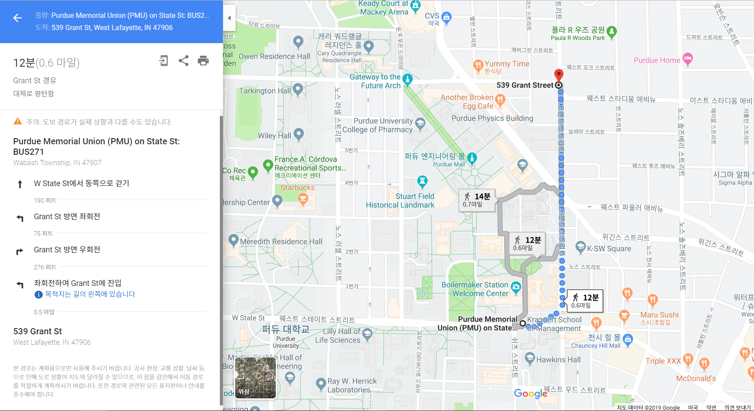

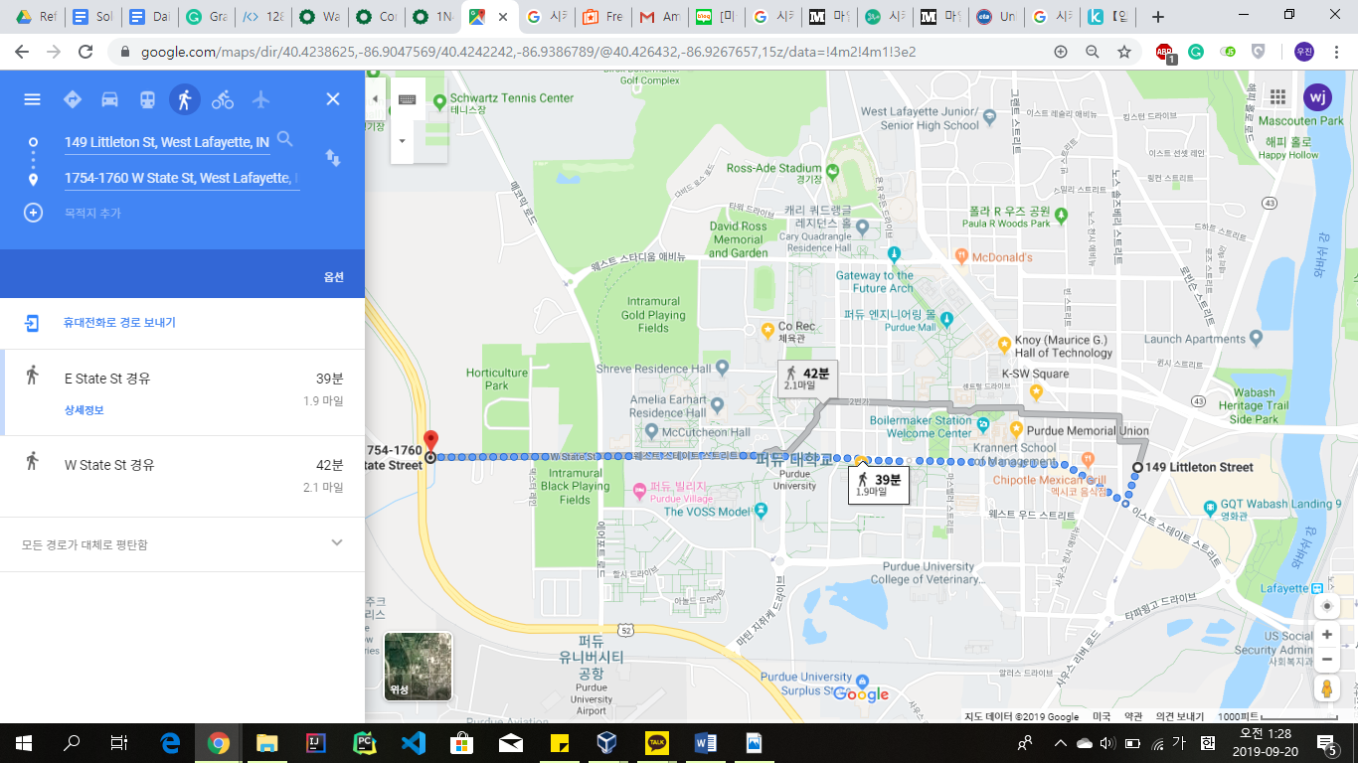

To Do

1. Design LoRa test environment before going to farm
2. Test sensors
3. Drawing modified circuit of APRS system

***2019.09.19 (Woojin)***

Done

1. Testing an APRS transmit distance ( checked that distance : 2.9km & signal strength : -85 ~ 90 dbm )
2. Get GPS antennas and antenna adapters
3. Get some parts for irrigation system
4. Drawing a LoRa network diagram

To Do

1. Testing a maximum distance of the current APRS transmit distance.
2. Testing a GPS sensor with the new GPS antennas
3. Testing a solenoid valve ( for irrigation system )
4. Drawing the APRS network diagram

***2019.09.20 (Hyuk)***

Done

To Do

1. Testing a maximum distance of the current APRS transmit distance.
2. Testing a GPS sensor with the new GPS antennas
3. Testing a solenoid valve ( for irrigation system )
4. Drawing the APRS network diagram

***2019.09.23 (Hye Won)***

Done

1. APRS에서 온도 습도 센서로 데이터 수신
2. irrigation 작동되는지 테스트
3. irrigation system 납땜
4. LoRa DHT11 connection
5. <https://wiki.dragino.com/index.php?title=MyDevices> tutorial 따라하기
6. APRS, ~~LoRA~~에 GPS 부착
   1. APRS용 GPS 다시 주문

To Do

1. (APRS와 LoRA 통신 거리 및 통신 소요 시간 테스트)
2. ~~토니 교수님께 농장 방문 요청~~
3. APRS network diagram
4. LoRa iGate setting

***2019.09.24 (pearl)***

Done

1. APRS network diagram 그리기
2. Watch LoRa tutorial video
3. Tony 교수님 연구실에서 APRS 스펙트럼 테스트

To Do

1.LoRa iGate setting

2. Actual power 알아내기

***2019.09.25 (lydia)***

Done

1. APRS network diagram 그리기
2. IoT 수업 회의

To Do

1. LoRa iGate setting
2. Irrigation system 테스트
3. data analytics 연락

***2019.09.26 (rani)***

Done

1. irrigation system high-level trigger 테스트 후 스위치로 작동 확인
2. VH400 테스트

To Do

1. irrigation high-level trigger 회로도 그리기
2. 내일 출장 준비

***2019.09.27 (혁)***

Done

1. 퍼듀 농장에서 APRS와 LoRa 통신 거리 테스트
2. APRS call sign 바꿈 (W1AW->KD9NDI)

To Do

1. 학교에서 APRS 통신 거리 다시 측정해보기
2. install LoRa antenna next to APRS antenna

***2019.09.30 (DJ)***

Done

To Do

1. irrigation high-level trigger 회로도 그리기

***2019.10.01 (DJ)***

Done

1. LoRa gateway register at Think Network and added device(Arduino Uno LoRa Shield) on Cayenne
2. Listened to LoRa YouTube tutorial
3. Pinged LoRa gateway to YouTube
4. Labeled preregistered LoRa gateways
5. Tested APRS outside of K-Square (Distance : 2.8 km)

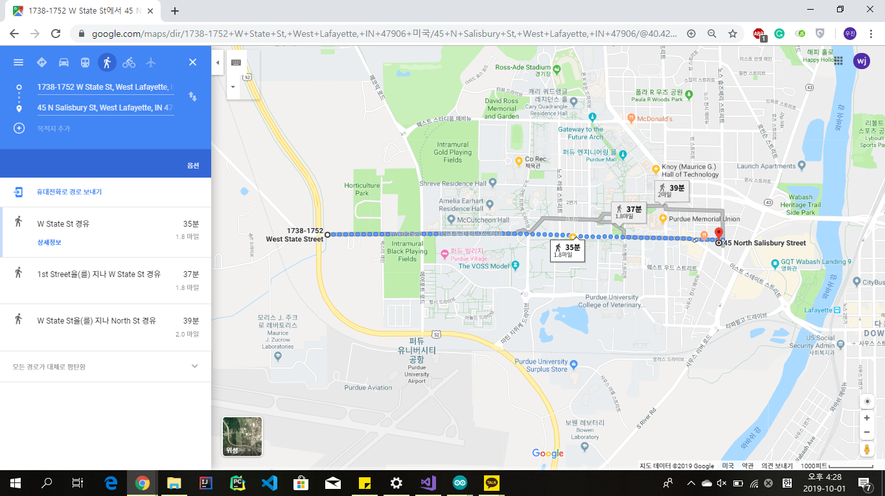

1. Drawed the irrigation system’s circuit diagram.
2. Tested the irrigation system’s new circuit (without external power supply) - failed
3. Decided what to do for IoT Data Analysis Project (Video Analysis : Dear Detection)

To Do

1. LoRa status fix it to connected
2. Change LoRa Gateway antenna
3. APRS 안테나 파워 측정
4. APRS 안테나 파워 올릴 방법 찾기

***2019.10.02 (Rebecca)***

Done

1. Made the dragino gateway connected
2. Registered Lora Shields (Transmitter and Receiver) to The Things Network & Cayenne
3. Installed libraries in Arduino required for Cayenne
4. Tried communicating LoRa Shields using MQTT

To Do

1. Make connections using MQTT

***2019.10.09 (Hye Won)***

Done

1. Tested APRS and LoRa at Purdue’s Farm but failed due to broken antenna
2. Found antenna for APRS(144MHz) and LoRa (902-928MHz ) => Professor Smith ordered for us

To Do

***2019.10.15 (Hye Won)***

Done

1. Group meeting : Team 시간표 작성
2. Checked the new antennas for APRS and LoRa
3. Start studying MQTT

To Do

|  |  |  |  |  |  |  |  |  |  |  |  |  |  |  |
| --- | --- | --- | --- | --- | --- | --- | --- | --- | --- | --- | --- | --- | --- | --- |
| **10/15 - To Do (전체) :** | | | **LoRa (동준, 혜원, 채희, 미란)** | | | **APRS (우진, 희재, 고운, 혁)** | | | **Irrigation System (동준, 혜원, 미란, 우진, 고운)** | | | **Data Analytics (희재, 우진, 채희, 혁)** | | |
| 1. 농장 Test | | | MQTT (Cayenne Mosquitto 정하기) | | | 안테나로 들어가는 전압 정확히 측정 | | | Logic 작성 (논의 예정) | | | 어떤 동물이 방해되는지 찾기 (새, 사슴 집중) | | |
| 2. 논문 작성 (APRS vs LoRa) | | | YouTube 영상 시청 | | | 외부 전원을 통해 출력 전압 세기 증가 | | | Irrigation 센서 연결 | | | 동물들 쫓는 효율적인 방법 찾기 | | |
|  | | | Sensor(Sensor,Actuator) 연결해서 환경 구축 | | | 다이오드 & 트랜지스터를 사용해 전압 세기 증가 | | | 다이오드 & 트랜지스터 사용 | | |  | | |
| 1. Final Report | | |  | | | 모든 센서 연결 | | | 최종 테스트 | | |  | | |
|  | | |  | | | 최종 테스트 | | |  | | |  | | |

***2019.10.16 (DJ)***

Done

1. APRS 전압 측정 실패: 약 800mA (600 ~ 900mA) - 다른 장비 필요함 (Tony 교수님이 주문해 줌)
2. Started studying MQTT
3. APRS에도 MQTT 적용시켜 보기로 함

To Do

1. Decide network topology for LoRa using MQTT
2. Studying MQTT for APRS

***2019.10.17 (Hyuk)***

Done

1. Test the distance of APRS network (6km)
2. Replace and test Antenna of LoRa
3. Install and test MQTT module for LoRa broker

To Do

1. Test the distance of APRS network at Purdue farm

***2019.10.18 (Arthur)***

Done

1. Test the distance of APRS network at the farm

( A repeater is in PMU, so it has good distance in Purdue Univ )

1. Test the distance of RoLa network at the farm

To Do

1. Studying transistor and diode for increasing antenna current
2. Studying MQTT for APRS
3. Write code for MQTT on LoRa

***2019.10.21 (Rebecca)***

Done

1. found MQTT-SN library
2. Keep studying MQTT for APRS
3. Studying how to amplify current using transistor and diode

To Do

1. Find way to run python codes on Arduino
2. Studying transistor and diode for increasing antenna current
3. GPS test for APRS using new antenna
4. Test the output electric power of APRS antenna

***2019.10.22 (Lydia)***

Done

1. Tested APRS-GPS sensor working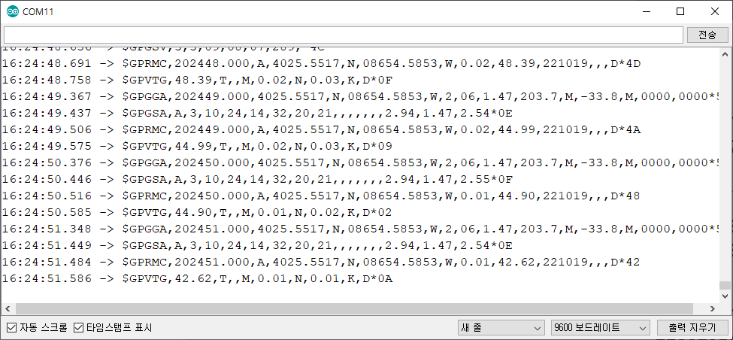
2. Tested output power for both APRS and LoRa (사진은 순서대로)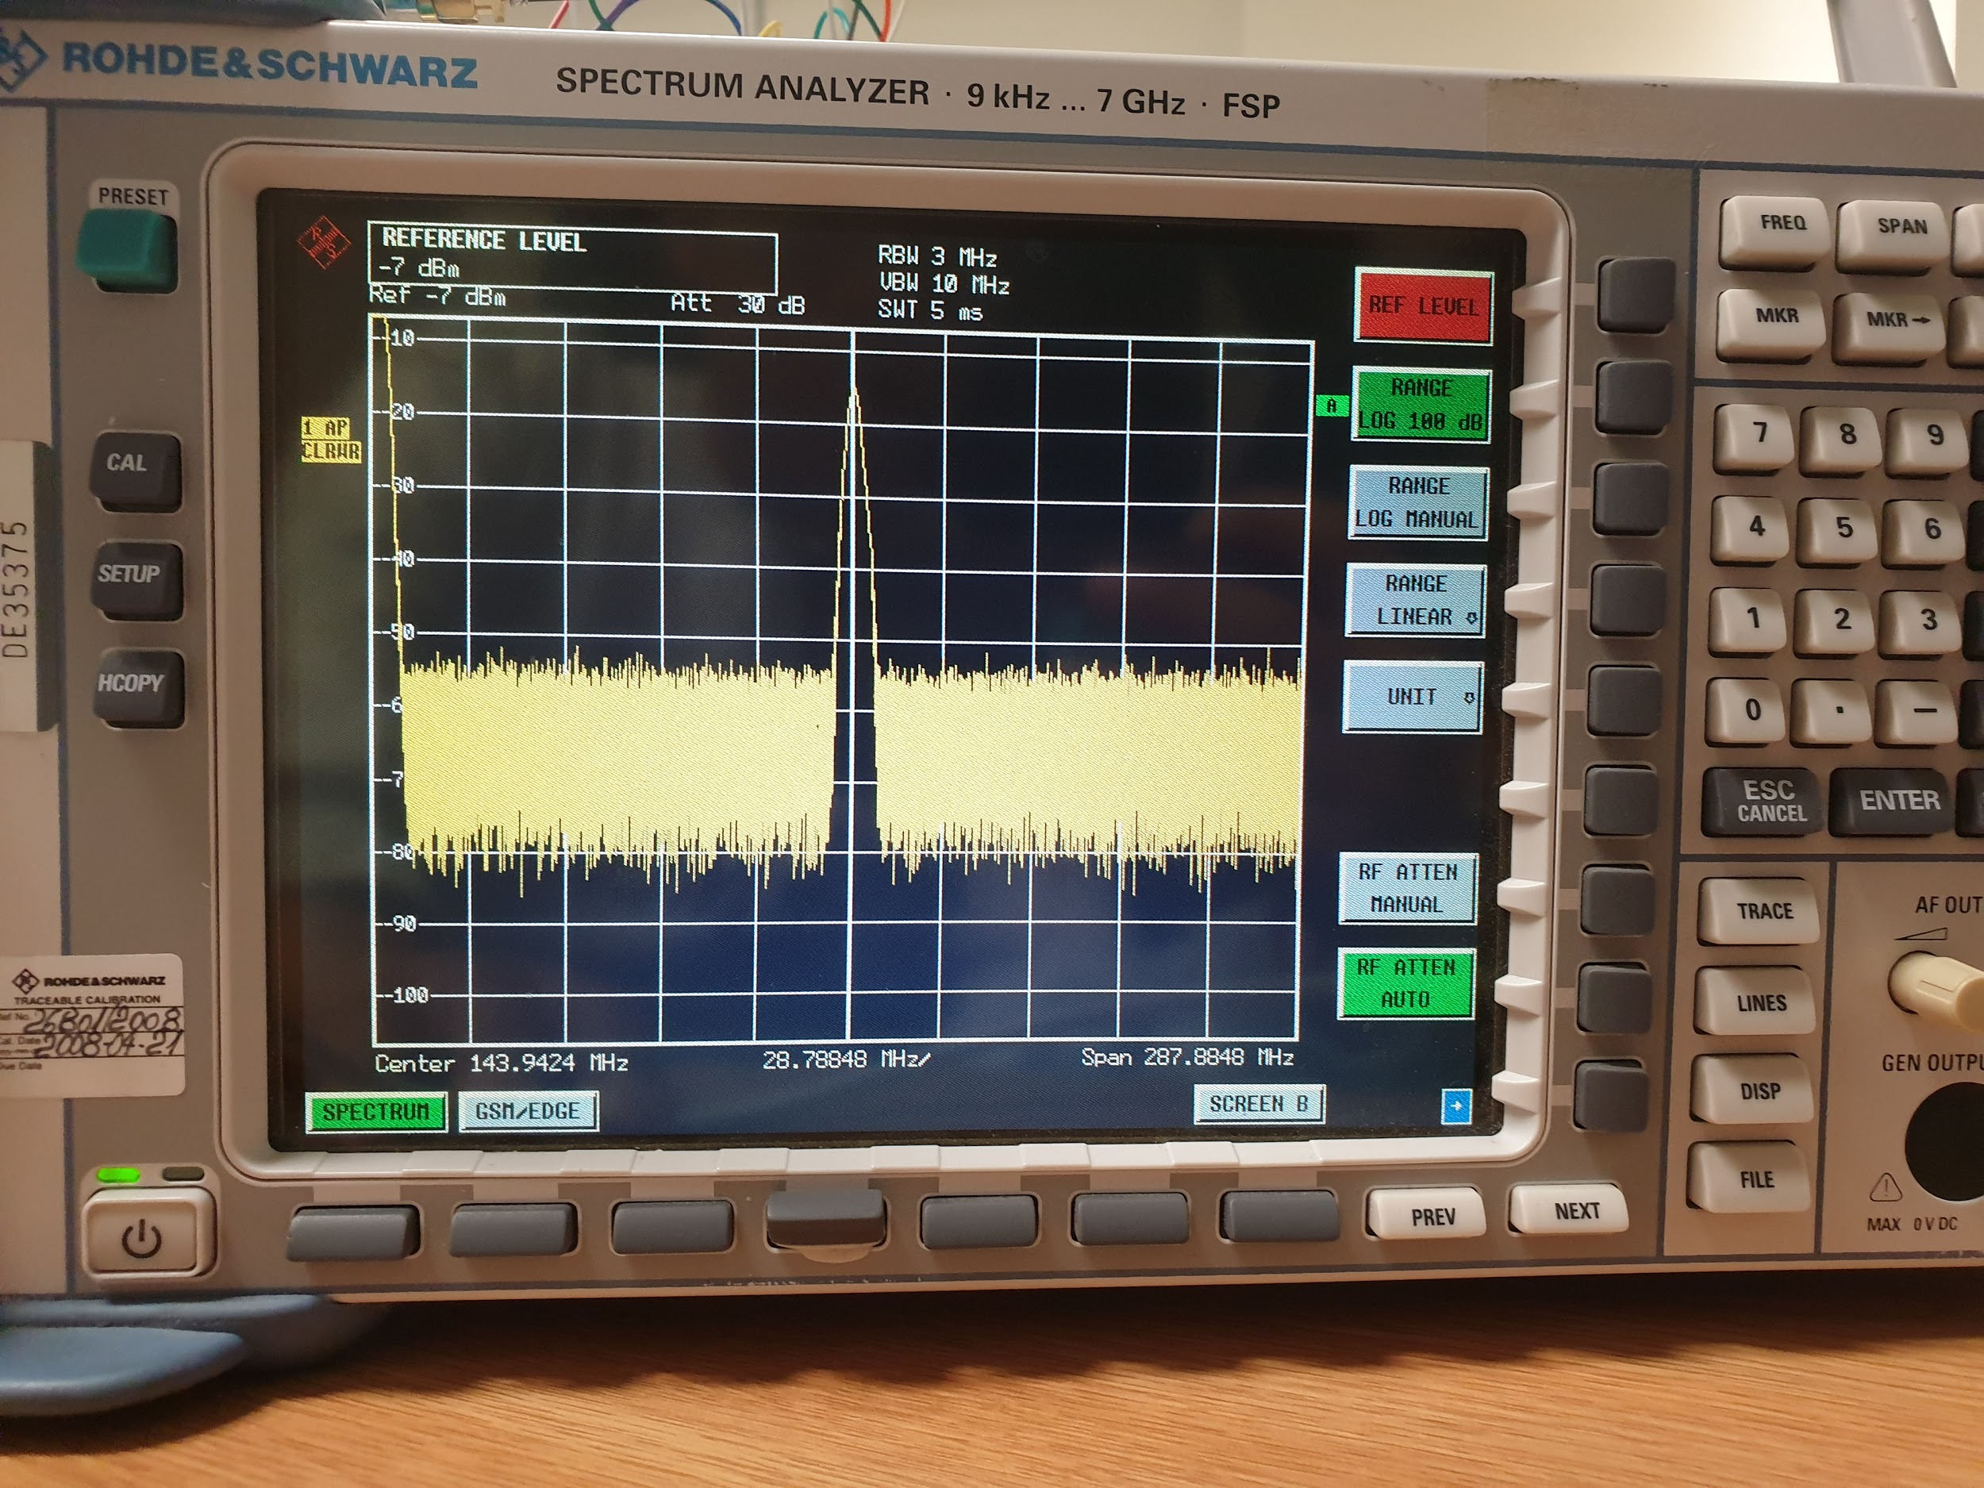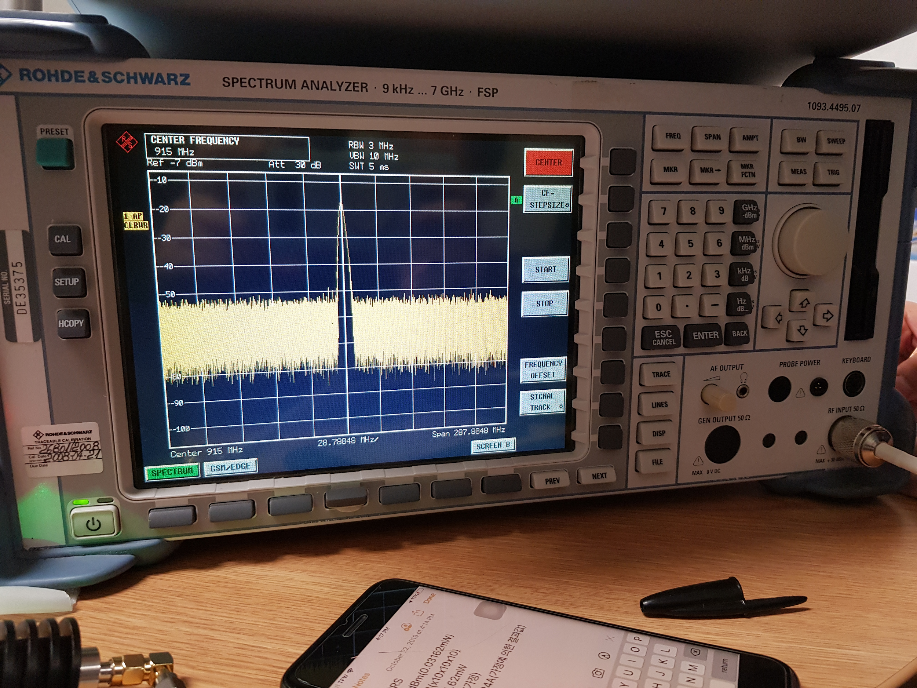

To Do

1. Study how to increase power in Arduino circuit
2. Study MQTT-APRS
3. Study MQTT-LoRa
4. Test GPS antenna with Arduino - APRS
5. Draw final circuit for APRS

***2019.10.23 (Pearl)***

Done

1. Tested GPS code and modified it (APRS)
2. Connected all sensors to the arduino (APRS)
3. Connected t/h sensor to the arduino (LoRa)
4. Asked Tony about MQTT problems - meeting tomorrow (LoRa)

To do

1. GPS is not working with other sensors (APRS)
2. Test sensors with arduino (LoRa)

***2019.10.24 (Ran)***

Done

1. Tested sensor(DHT11,VH400) with arduino(LoRa)
2. Merged transmitting code with sensor (LoRa)
3. Studied MQTT and Transgister (APRS)

To do

1. Test GPS code (LoRa)
2. Modify the code to work GPS with other sensors (APRS)

***2019.10.25 (Hyewon)***

Done

1. Tested APRS with all sensors.

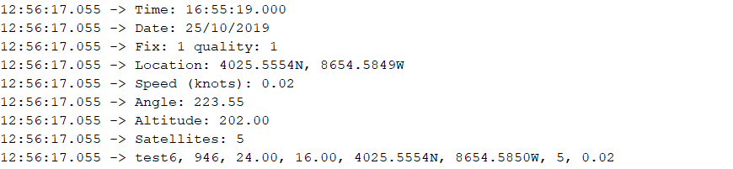

***2019.10.28 (DJ)***

Done

1. Tested Actuator to the Arduino(LoRa)
2. Studied transistors

To do

1. Refactoring LoRa transmit code
2. Test MQTT communication between gateway and broker

***019.10.29 (Brian)***

Done

1. Trying to increase the current of Arduino (APRS)
2. Made Arduino code where Lora End Device sends data to TTN Gateway
3. Succeed receiving lora packets at Lora Gateway
4. Succeed connecting Lora Gateway to TTN Gateway

To do

1. MQTT communication using Raspberry pi (APRS)

***2019.10.30 (Rebecca)***

Done

1. Install OS and GNU on Raspberry Pi for APRS Gateway
2. Raspberry Pi Lora Gateway received DHT11 data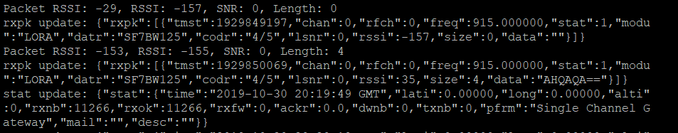
3. LoRa Gateway - MQTT Broker succeed MQTT
4. Finished making DHT11 arduino code that sends to Cayenne and TTN

To do

1. Test new LoRa Antenna (LoRa)
2. Make Data show up at TTN Gateway Traffic and Cayenne Database
3. Keep making environment on Raspberry Pi for APRS Gateway

***2019.10.31 (아서)***

Done

1. Fail to increase the current of Arduino (APRS)
2. Order RTL-SDR dongle
3. Making Data show up at TTN Gateway Traffic and Cayenne Database

To do

1. Try to set MQTT communication using Raspberry pi (APRS)
2. Keep making Data show up at TTN Gateway Traffic and Cayenne Database

***2019.11.1 (Lydia)***

Done

1. Tried Raspberry Pi Configuration for APRS iGate

To do

1. Connect Thingspeak with LoRa, for alternative to fail when only used TTN(LoRa)
2. Connect SDR on Raspberry Pi

***2019.11.2 (Chaehee)***

Done

1. Made the soil moisture sensor work with the arduino (LoRa)
2. Succeed getting lora end device datas to TTN by Lora Gateway (RPI)
3. Succeed getting data from lora end device to Cayenne (LoRa)
4. (LoRa)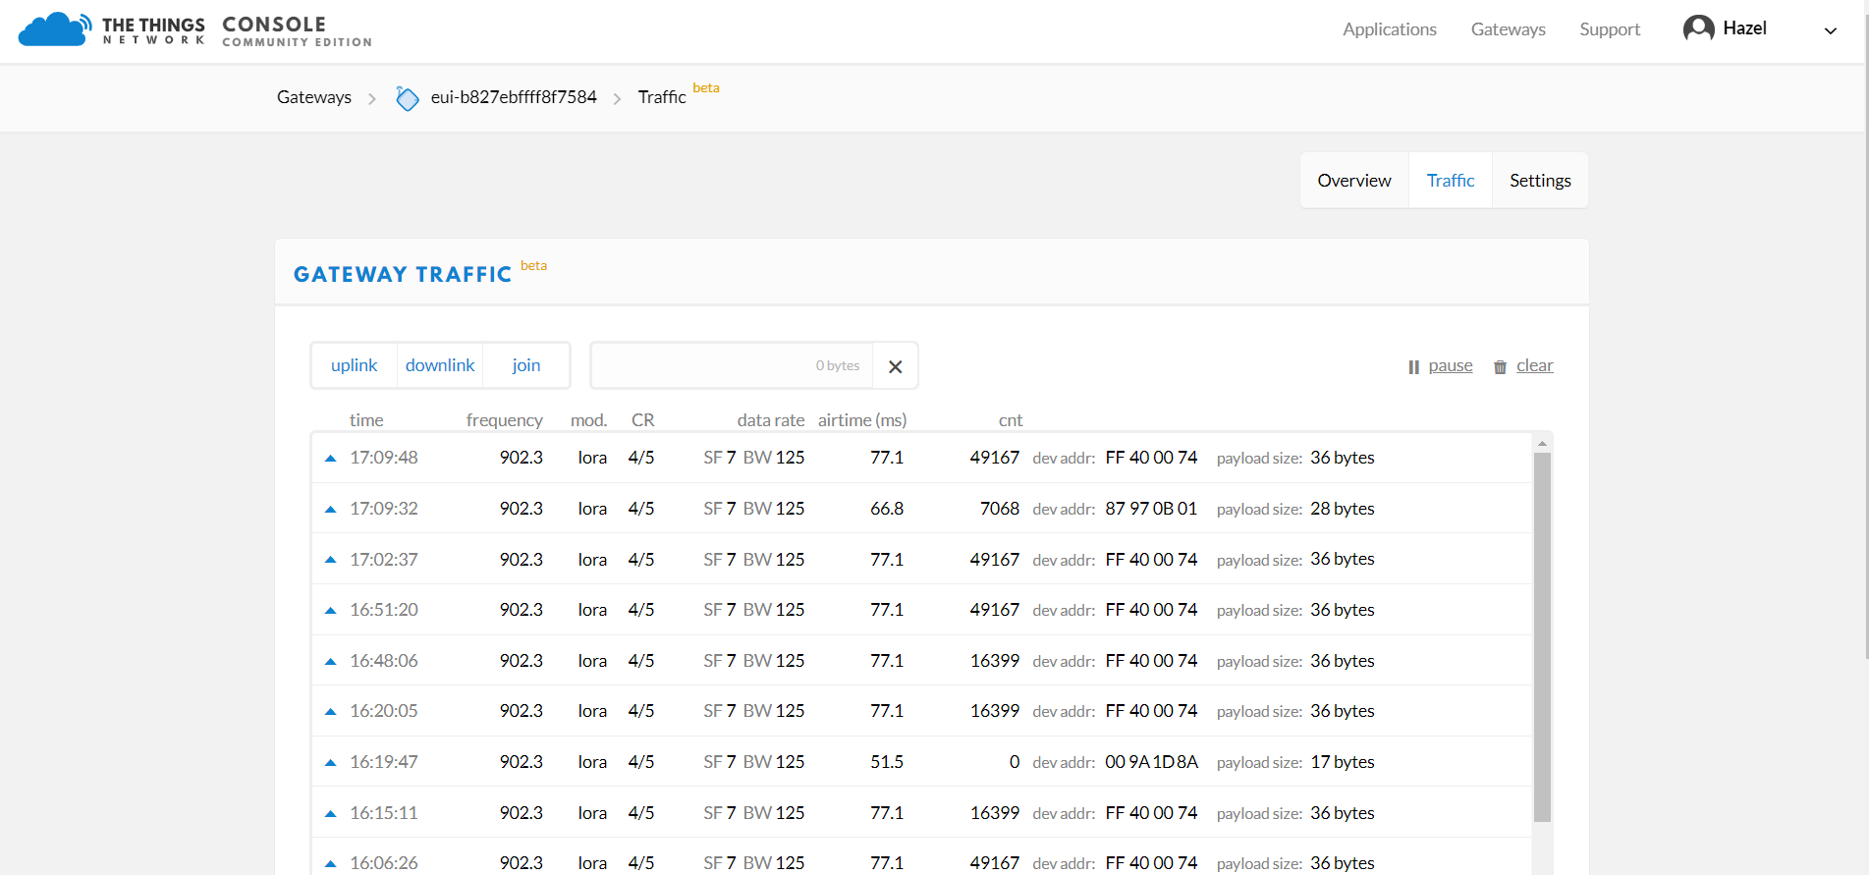
5. (LoRa)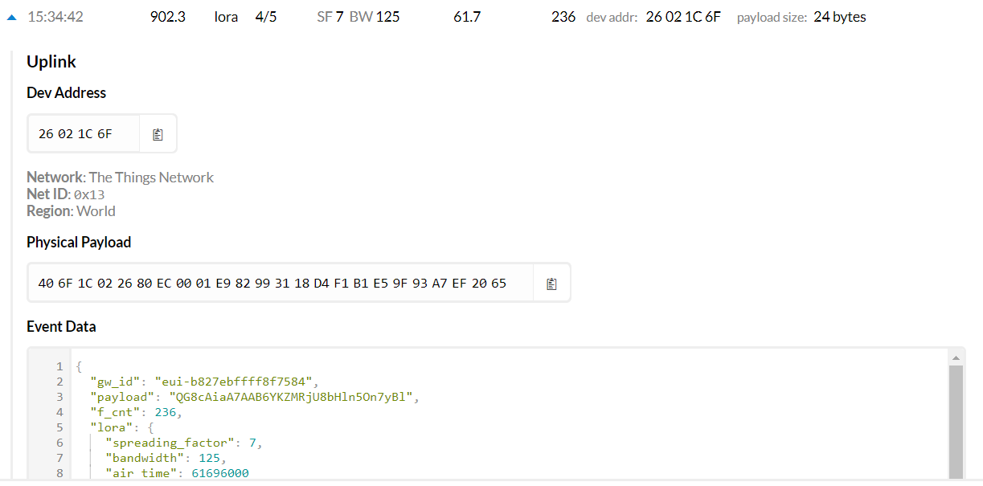
6. (LoRa)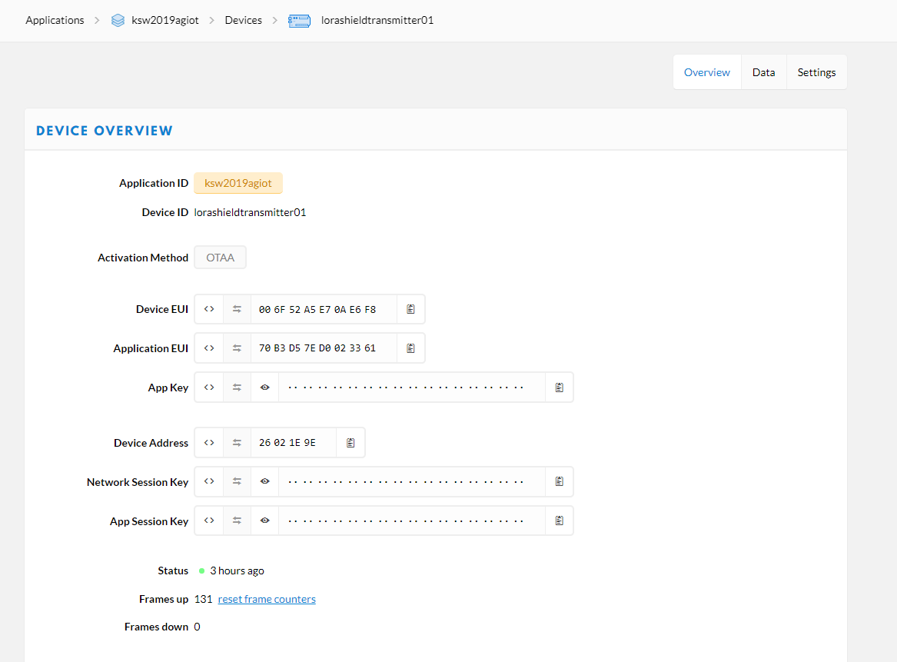
7. (LoRa)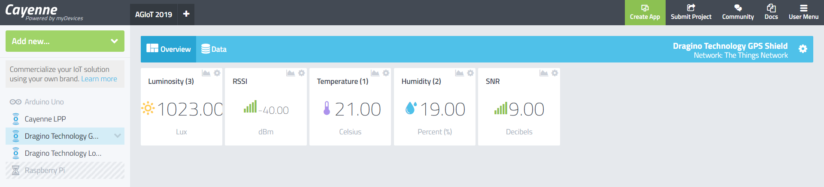

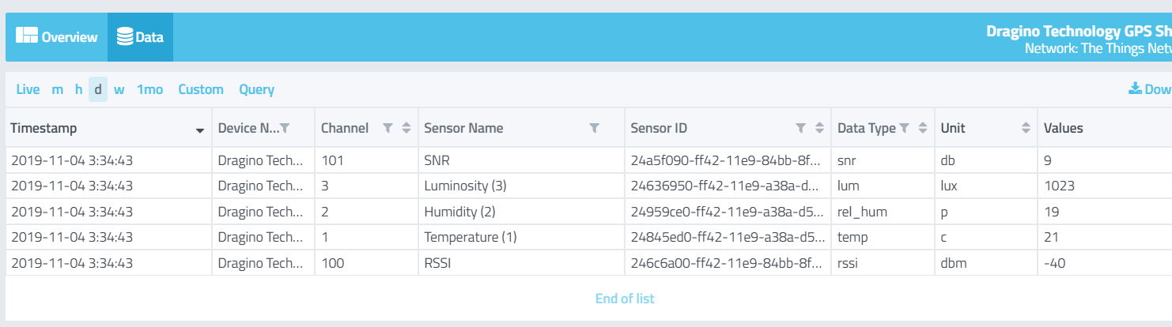

To do

1. Meeting & reschedule (APRS)
2. Study MQTT(APRS)
3. Stabilize TTN Gateway (LoRa) : Single_Chan_Packet_Forwarder code 수정해서 매번 refresh하기 (새로고침할때만 성공함)
4. MQTT SN over LoRa 코드 돌아가게 하기 (LoRa)

-> 값 찾기

1. LoRa Downlink 성공하기

***2019.11.3 (RANI)***

Done

1. Succeed receiving and saving Lora End Device Information at MQTT Broker (RPI) by TTN using MQTT(LoRa)

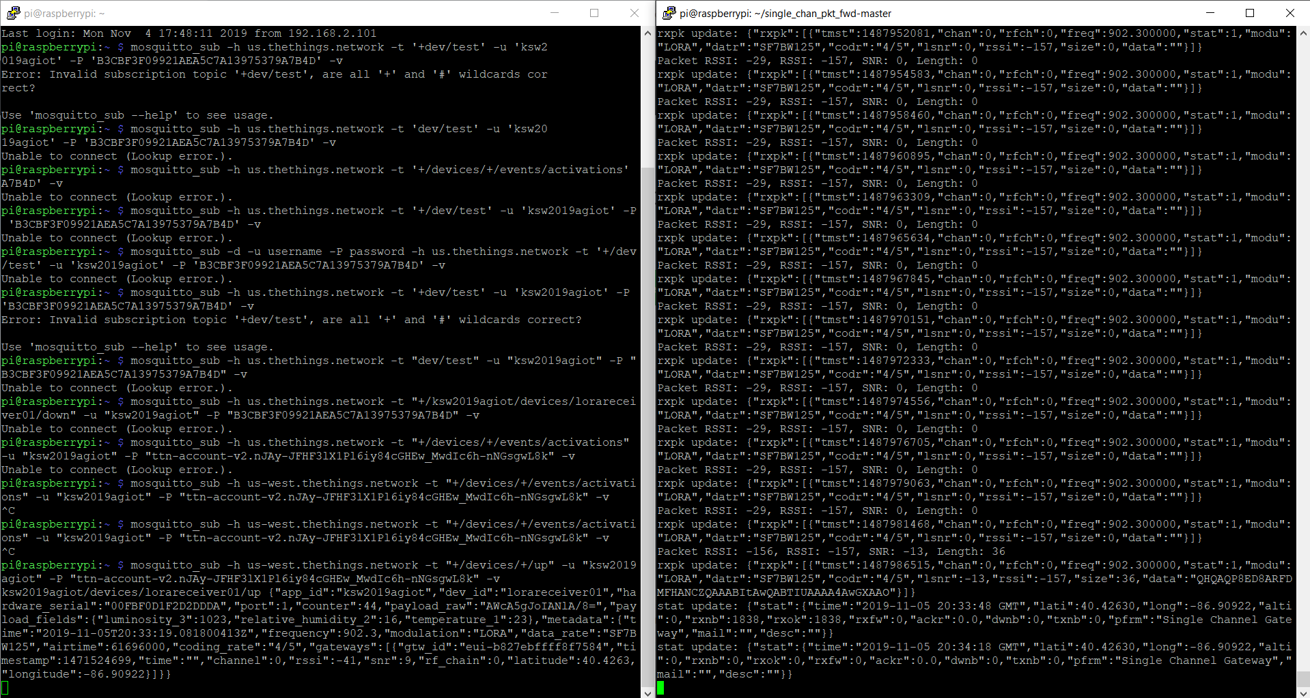

1. Succeed connecting Arduino(receiver) to Raspberry pi(server) using LoRa.
2. Succeed testing soil moisture sensor using YL-69 instead of VH400.

---------------------------------------------------------------------------------------------------------------------------------------

***2019.11.12 (HYEWON)***

Done

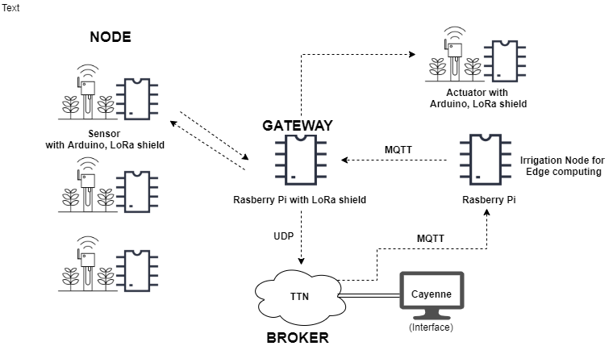

1. Contacted Hershel and Britt to decide who to work with the irrigation edge logic

=> Result: waiting for volunteers …

1. Talking to Prof. Smith about the AGIoT Diagram (where the MQTT bro0eker is TTN)

To DO

1. Irrigation Node for Edge Computing:
   1. Research best threshold+irrigation logic - Miran
   2. Start writing code in main.c (Logic) - Hyewon
   3. ~~Parsing - Pearl~~
   4. ~~Weather API - Miran~~
   5. ~~controlling actuator - DJ~~
2. Integrate Shell

***2019.11.13 (DJ)***

Done

1. Irrigation Node for Edge Computing:
   1. Weather API
   2. controlling actuator
   3. Parsing

To do

1. Research best threshold+irrigation logic -> To be discussed with Perry

***2019.11.14 (HYUK)***

Done

1. Succeeded combining all shells for RPI Gateway (packet forwarding & mqtt subscriber & sending to arduino actuator)

./total.sh

1. Succeeded connecting all ecosystem flow together

(Changed Edge Node Mosquitto publisher code to python using paho)

1. Contacted Prof. Perry for advice
2. Built an iGate for APRS
3. Succeeded testing at the Avenue South (Approx 180-200m for APRS)

To do

1. Edit main.c (edge logic) after getting Prof. Perry’s advice
2. Test receiving data from the sensor packet to the iGate

***2019.11.15 ()***

Done

1. Researched Conferences

To do

1. Meet Prof. Perry on Tuesday

2019.11.21

Done

1. 최종 발표 회의

APRS vs LoRa: 발표 - 혁 / PPT - 고운

LoRa: 발표 - DJ / PPT- 라니

mqtt: 발표 - 희재 / PPT - 우진

1. 로라 웹페이지 제작 회의

***2019.12.5 () - Hye Won***

Done

1. LoRa Website Database
2. LoRa Website most of front and back end
3. Started writing paper for LoRa vs APRS

To do